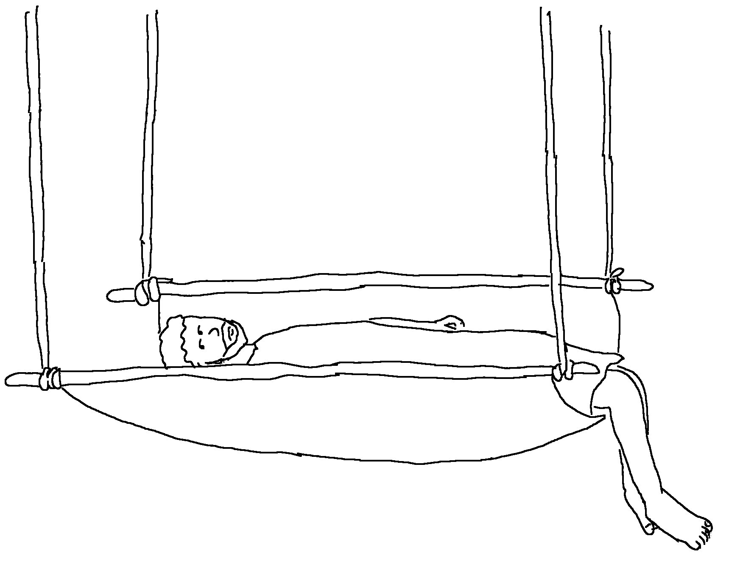
Only _ _ _ can _ _ _ _ _ _ _ sins!
Mark 2:7 _{NLT}

